**Project 01 - Recipe (40pts)**

Create a page that displays a recipe. You can use any recipe you want, but it **must** follow this format:

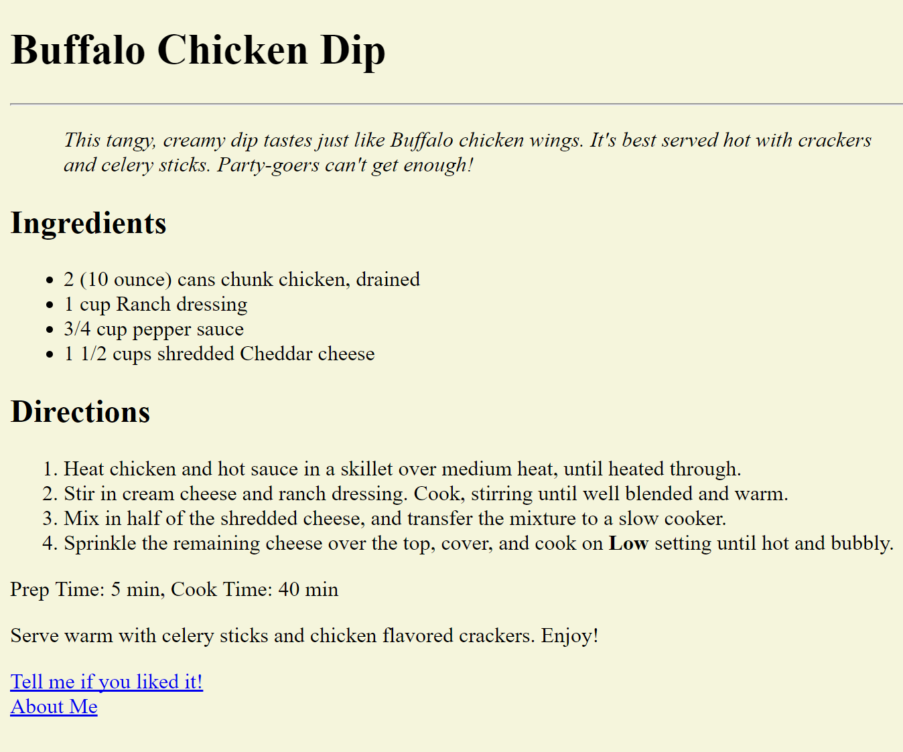

Requirements:

* Use a light ba­­­ckground and black text
* Use a heading and subheadings
* Use 2 lists - ordered & unordered
* Include a link so a reader can email you
* Include another link to the last version of your “about me” page

Don’t forget:

* Include comments - name, assignment, date and basic info throughout code
* Save the file as a .html file
* Upload the recipe .html file & the last version of your About Me .html file to OnCampus